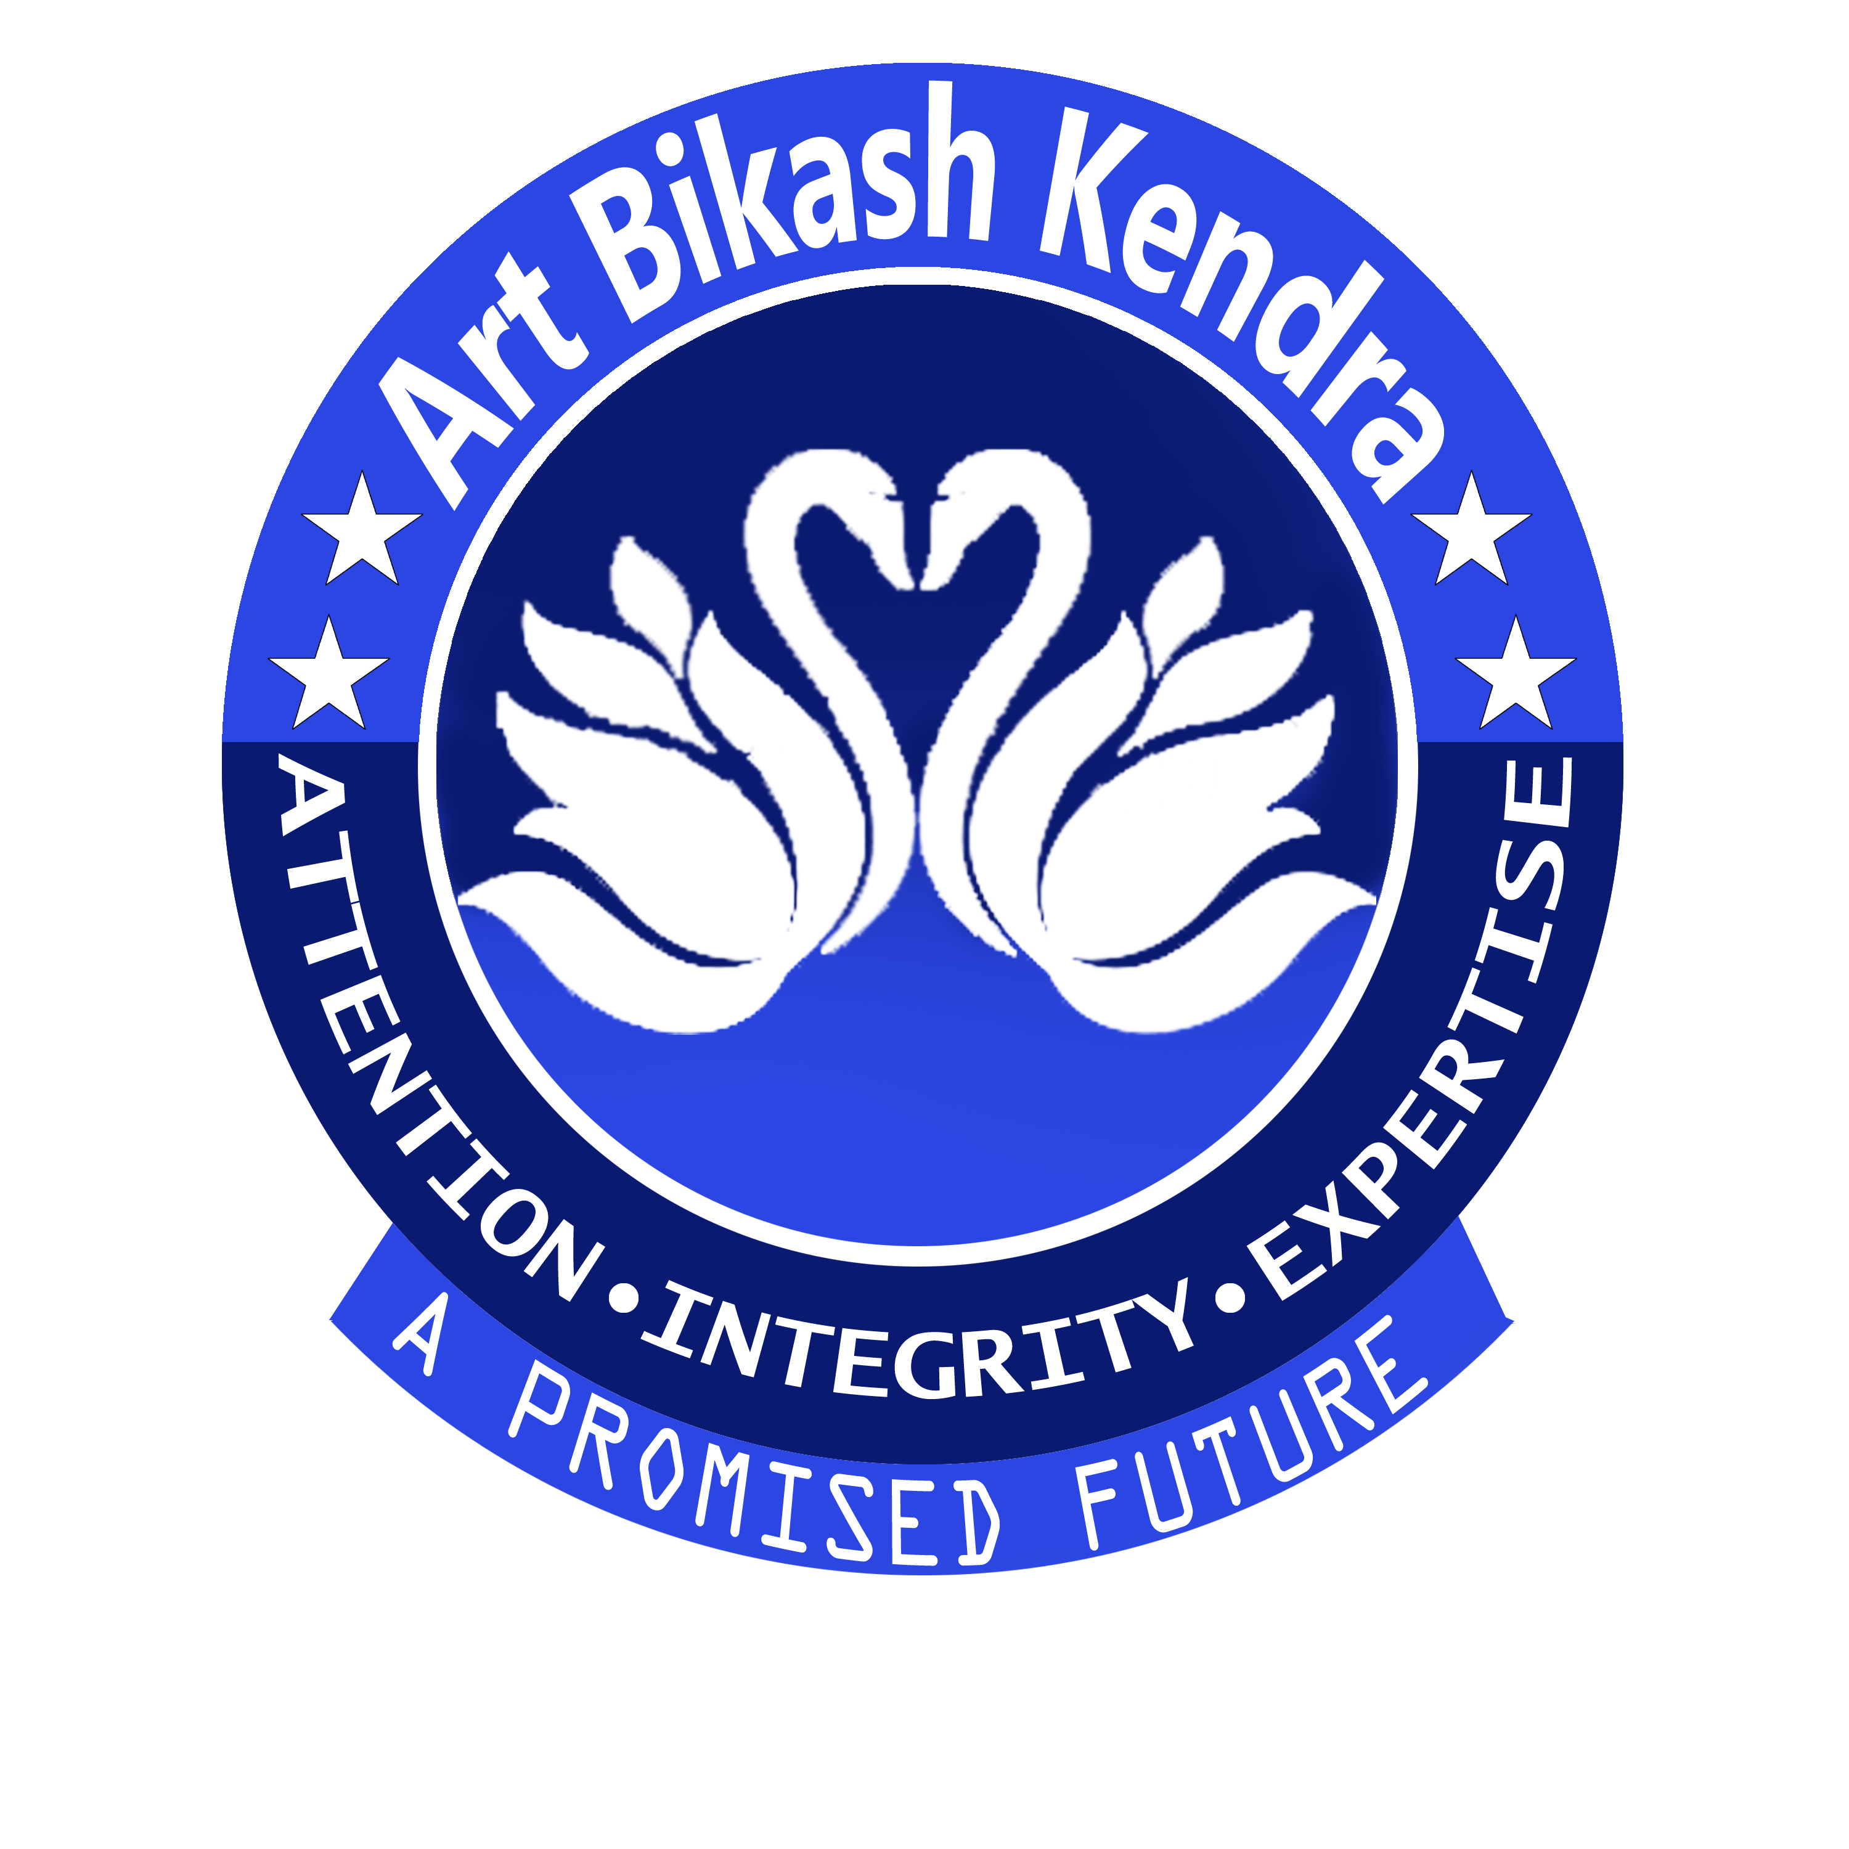
ART BIKASH KENDRA
ORGANIZATION
Sincerely,
To,
Honourable guest,
Subject : Invitation Letter to a Guest of Honour
Respected sir,

I am very pleased to inform you that your presence is requested at our annual drawing exam ceremony as guest of honour. We are conducting a small event, where different participants will compete with each other in many drawing. Winners will be given prize and honoured by you.
You are warm heartedly invited. Thank you very much for your time and consideration.

Program Venue –
Program Date –
Program Time –
NAME_________
TEACHER
14 no Word, Bishnupur
Bankura, WB, 722122
(+91) 790-8675-962
www.artbikashkendra.com
PO-Bishnupur, PS-Bishnupur
Bankura, Pin-722122, WB, India
Session: 2022

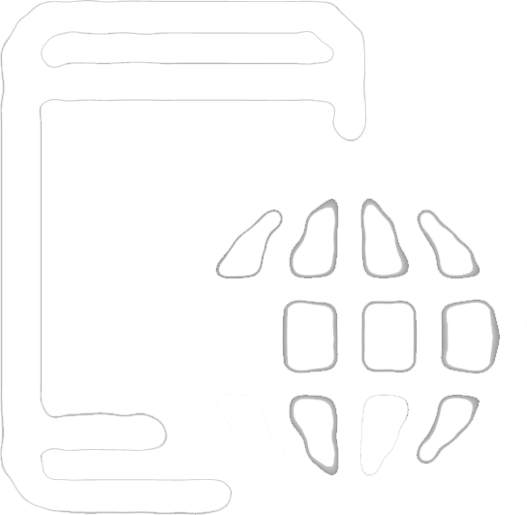
Phone +91 790-8675-962
Phone +91 956-3016-810
Online appointment booking
through website is acceptable
www.artbikashkendra.com

